MOVEMENT

- It is the direction your eye travels
.
- Visual movement is used by the artist to direct viewers through their work, often to a focal area.

- The eye moves most easily on paths of contrast. Movement can be directed along lines, edges, shapes and colors.

Video link: http://youtu.be/Zq76PzuVyiw

*Tutorial on inserting arrows to identify eye movement next page
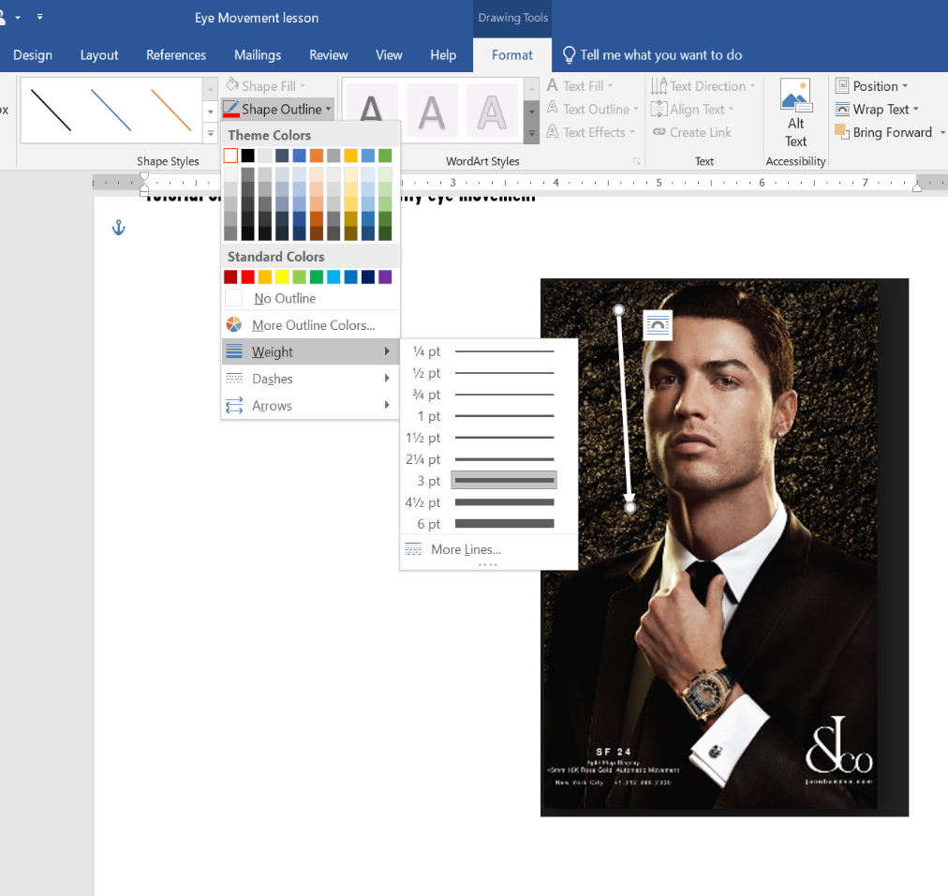

- Include 3 pictures/ images
- Use arrows to show the direction your eye travels
- Look on the next page for instructions to add arrows
Sample 

